**ADXL345**

**What is ADXL345?**

he ADXL345 is a versatile and compact accelerometer sensor that is widely used in various applications, ranging from consumer electronics to industrial systems. Developed by Analog Devices, it is a small, low-power, three-axis accelerometer that measures acceleration in both static and dynamic conditions. The ADXL345 utilizes micro-electro-mechanical systems (MEMS) technology to detect changes in motion and orientation across three axes (X, Y, and Z) and provides precise digital output. This sensor is popular for its ease of integration, accuracy, and its ability to measure acceleration across a wide range. It finds applications in devices such as smartphones, tablets, gaming controllers, and fitness trackers, as well as in industrial and automotive systems, where monitoring motion and vibration is crucial for safety and performance.

The ADXL345 offers a range of features that make it highly suitable for motion and acceleration sensing applications. It can measure accelerations in a range of ±2g, ±4g, ±8g, or ±16g, allowing it to capture a wide spectrum of movements, from subtle tilts to rapid accelerations. Additionally, the sensor incorporates advanced digital signal processing, enabling it to provide precise and stable output data. It communicates with external devices via various interfaces, including I2C and SPI, making it easy to interface with microcontrollers and other electronics. Furthermore, the ADXL345 is known for its low power consumption, making it an efficient choice for battery-operated devices.

The ADXL345 has gained popularity in applications such as screen orientation detection in smartphones and tablets, pedometers for step counting, impact and shock detection in industrial equipment, and various motion-based gaming peripherals. Its versatility, accuracy, and compact form factor have solidified its position as a staple sensor in the world of motion and acceleration sensing, contributing to the development of innovative and responsive electronic devices and systems.

The ADXL345 also features several built-in functions that enhance its versatility. One of these functions is free-fall detection, which allows the sensor to identify when it is in free-fall and trigger an interrupt. This can be particularly useful in applications where detecting a sudden drop or impact is crucial for safety or monitoring purposes.

Another noteworthy feature is its high resolution and adjustable data output rates, which enable users to tailor the sensor's performance to their specific requirements. The ADXL345's low noise level and wide measurement bandwidth further contribute to its ability to capture precise and detailed motion data. In addition to its widespread use in electronic gadgets and industrial equipment, the ADXL345 is frequently employed in research and development, especially in the fields of robotics, motion analysis, and structural health monitoring. Researchers and engineers appreciate its reliability and ease of use in projects where precise acceleration and motion measurements are essential for understanding and optimizing performance. Its compact design and compatibility with a wide range of microcontrollers and development platforms make it a popular choice for prototyping and experimentation in the ever-evolving world of motion sensing technology.

**Working:**

The ADXL345 is a popular three-axis digital accelerometer that operates on the principles of micro-electromechanical systems (MEMS) technology. This compact sensor is designed to measure acceleration in three perpendicular axes: X, Y, and Z. It works by detecting changes in capacitance within its tiny, precisely manufactured silicon structures. When an acceleration force is applied to the sensor, the mass within these structures shifts, causing a change in capacitance. This change is then converted into a voltage signal, which is subsequently digitized and processed by an integrated analog-to-digital converter (ADC). The resulting digital data is accessible via I2C or SPI communication protocols and can be used for a wide range of applications, including motion detection, tilt sensing, and vibration analysis, making the ADXL345 a versatile and essential component in various electronic devices and systems.

The ADXL345 features a built-in digital signal processor (DSP) that allows for flexible and precise acceleration measurements. It offers selectable measurement ranges (sensitivity) and data resolution to suit different applications. The sensor can operate in either full resolution mode, where it provides 13-bit data for high precision, or in a lower resolution mode (10-bit) to conserve power. The ability to switch between these modes makes it adaptable to both high-precision and power-efficient requirements.

Furthermore, the ADXL345 incorporates several built-in features like data rate selection, activity and inactivity detection, and free-fall detection, which enable it to perform specific tasks such as detecting when a device is in motion or at rest. Additionally, it includes a tap and double-tap detection mechanism, making it suitable for gesture recognition in various consumer electronic devices.

The ADXL345 is commonly used in applications like gaming controllers, smartphones, tablets, fitness trackers, and industrial equipment to measure acceleration and tilt. Its straightforward interface, high sensitivity, and programmable functionalities make it a valuable component in designing devices that rely on motion sensing and data collection. The sensor's low power consumption also makes it suitable for battery-operated applications, contributing to its widespread use in the electronics industry.

**Features:**

* Digital Output: SPI / I2C
* Low Power Consumption
* Compact Accelemotor / inclinometer
* 5V/3.3V input support.
* PCB Board Size: 28mm x 14 mm
* lower pressure drop than the 1117 Onboard RT9161 chip power
* ideal for noisy power environment

**Pin out:**

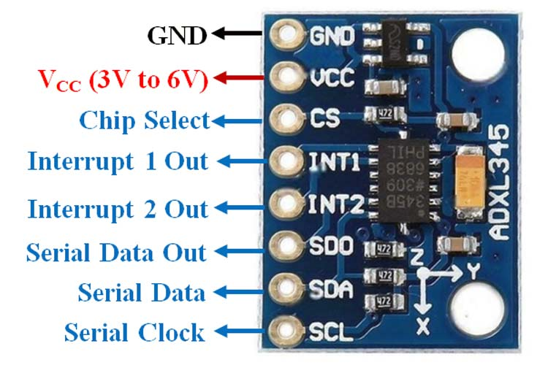

**ADXL345 Interfacing with Raspberry Pi:**

Interfacing the ADXL345 accelerometer sensor with a Raspberry Pi is a straightforward process that allows for precise motion and orientation sensing within the popular single-board computer. The ADXL345 is a digital accelerometer that can measure acceleration in three axes and communicates its data through the I2C or SPI communication protocols. By connecting the ADXL345 to the Raspberry Pi's GPIO pins and utilizing appropriate libraries and Python programming, you can easily read acceleration data and incorporate it into various projects. Whether it's for monitoring the movement of a robotics platform, tracking gestures in a wearable device, or creating a tilt-sensitive gaming controller, the ADXL345 and Raspberry Pi combination offers a versatile and accessible solution for adding motion sensing capabilities to a wide range of applications.

Interfacing the ADXL345 accelerometer sensor with a Raspberry Pi opens the door to a multitude of exciting projects that involve motion and orientation detection. This sensor is incredibly versatile, providing high-resolution data on acceleration and tilt in three dimensions. With the Raspberry Pi's computational power and GPIO flexibility, you can easily read and process this data, making it ideal for applications like gesture recognition, activity tracking, robotics, and more. By installing the necessary Python libraries and writing code to communicate with the ADXL345 sensor over the I2C or SPI interface, you can access real-time information about the position and movement of objects or devices. This can be particularly valuable in projects where precise motion control and monitoring are essential. Whether you're a hobbyist looking to build a motion-controlled robot or a developer exploring the world of IoT (Internet of Things), the ADXL345 and Raspberry Pi combo provides a user-friendly and powerful platform for motion-sensing applications.

